Meeting Agenda: Synthetic Data & Model Scope Definition
Project: Synthetic Fraud Pattern Modelling (ORIGIN) Student: Tonmoy Saha Choyon Date: 30th January 2026

Part 1: Defining the Data Structure (The "Input")
Goal: To ensure the synthetic data we build matches the actual system architecture.
Question 1: The Schema Template
"We have the Feature List from the Excel file, but do you have a 'Golden Template' or JSON Schema for a single upload event that you can share with us?"
- Why I am asking (Internal Note): I cannot generate data if I don't know the structure. Is it a flat CSV row? Is it a nested JSON object where one "Upload" contains 10 "Songs"?
- Elaboration Script (If they ask, "Why do you need this?"): "The Excel file lists the features, but not the hierarchy. For example, does the id_device_fingerprint sit at the 'Account Level' or the 'Upload Level'? Knowing the exact schema ensures my synthetic data can be ingested by your system without errors."
Question 2: Statistical Baselines
"To make our synthetic simulation realistic, can you provide rough statistical baselines for 'Normal' user behavior?"
- Why I am asking (Internal Note): I need to program the "Good" bots. If I make them upload too much, the model will fail.
- Elaboration Script: "For instance, does an average independent artist upload 1 single a month, or 1 album a year? Having this 'Ground Truth' allows me to calibrate the background noise so the anomalies actually stand out."

Part 2: Defining the Fraud Scenarios (The "Target")
Goal: To pick one specific problem to solve first.
Question 3: The Primary Attack Vector
"For the MVP (Minimum Viable Product), which specific fraud 'Attack Vector' do you want us to prioritize simulating first?"
- Why I am asking (Internal Note): I have 3 months. I can't simulate everything. I need them to pick one:
  - Option A: Bot Farms (High Volume / Velocity).
  - Option B: Metadata Spoofing (Fake Artist Names).
  - Option C: Asset Recycling (Re-uploading the same song).
- Elaboration Script: "We can simulate multiple types of fraud, but focusing on your biggest pain point first (e.g., Bot Farms vs. Copyright Theft) ensures we deliver a working prototype faster."

Part 3: Methodology & Tools (The "How")
Goal: To confirm my toolset is approved.
Question 4: Tooling Approval (Wolfram)
"I plan to use Wolfram Mathematica for the statistical probability modelling and initial data generation, as it offers superior distribution handling. Is this acceptable for the research phase, provided we export the final datasets as standard CSV/JSON?"
- Why I am asking (Internal Note): This is my "Safety Net." I am faster in Wolfram. I need them to say "Yes."
- Elaboration Script: "Wolfram is excellent for generating complex probability distributions (like non-normal distributions for bot behavior). Since the deliverable is the Data and the Logic, the tool used to generate it shouldn't matter as long as the output is compatible with your Python stack."
Question 5: The "Cold Start" Rules
"Since this is likely a 'Cold Start' model (unsupervised), are there any specific hard rules or 'Blacklists' you currently use that we should incorporate as features?"
- Why I am asking (Internal Note): This gives me "Easy Wins."
- Elaboration Script: "For example, do you already have a list of banned IP ranges or 'high-risk' keywords? If so, I can build those in as hard constraints to improve the model's baseline accuracy immediately."

Part 4: Logistics & Timeline
Goal: To set clear expectations.
Question 6: Data Flow Visualization
"Is there an existing high-level diagram of the data flow from Artist to Distributor? Seeing the visual pipeline would help us understand exactly where our 'Firewall' sits in the architecture."
- Why I am asking (Internal Note):
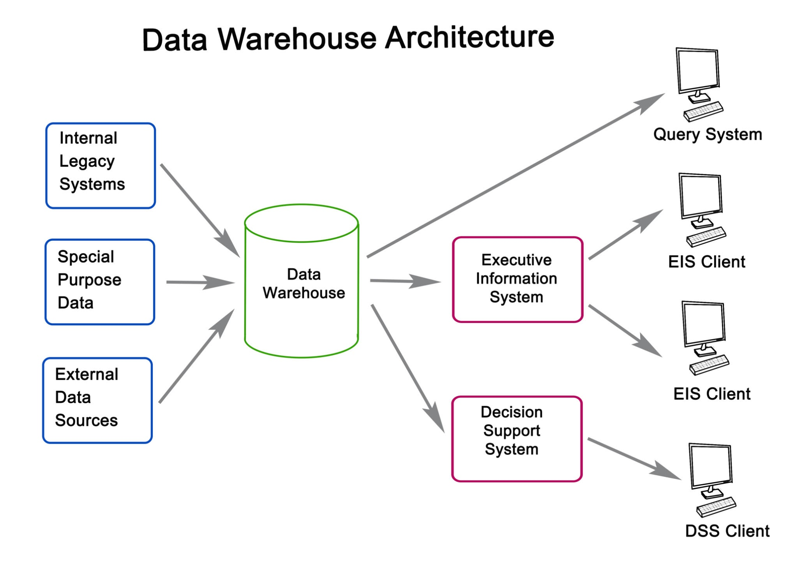
Getty Images
Explore
A picture is worth 1,000 words. It might reveal technical details they forgot to mention (e.g., "Oh, we also check the bank account").
- Elaboration Script: "It helps to visualize if this model runs synchronously (in real-time while the user waits) or asynchronously (in a batch process later). That dictates how fast the model needs to be."
Question 7: Success Metrics
"How do you define 'Success' for this synthetic dataset? Is it the volume of data generated (e.g., 100k rows), or the complexity of the hidden patterns?"
- Why I am asking (Internal Note): I need to know how to get an "A" grade from them.
- Elaboration Script: "I want to ensure I optimize for the right metric. If you need massive scale to stress-test your system, I will focus on performance. If you need subtle, hard-to-detect fraud patterns, I will focus on the complexity of the simulation."

Part 5: Next Steps (The Closing Script)
"Thank you. Based on this, my plan is to:
- Wait for the Schema Template from you.
- Build a small sample dataset (50 rows) focusing on [Insert their chosen Attack Vector].
- Send that sample to you for review by [Insert Date - e.g., next Friday].
Does that sound like a good plan?"

